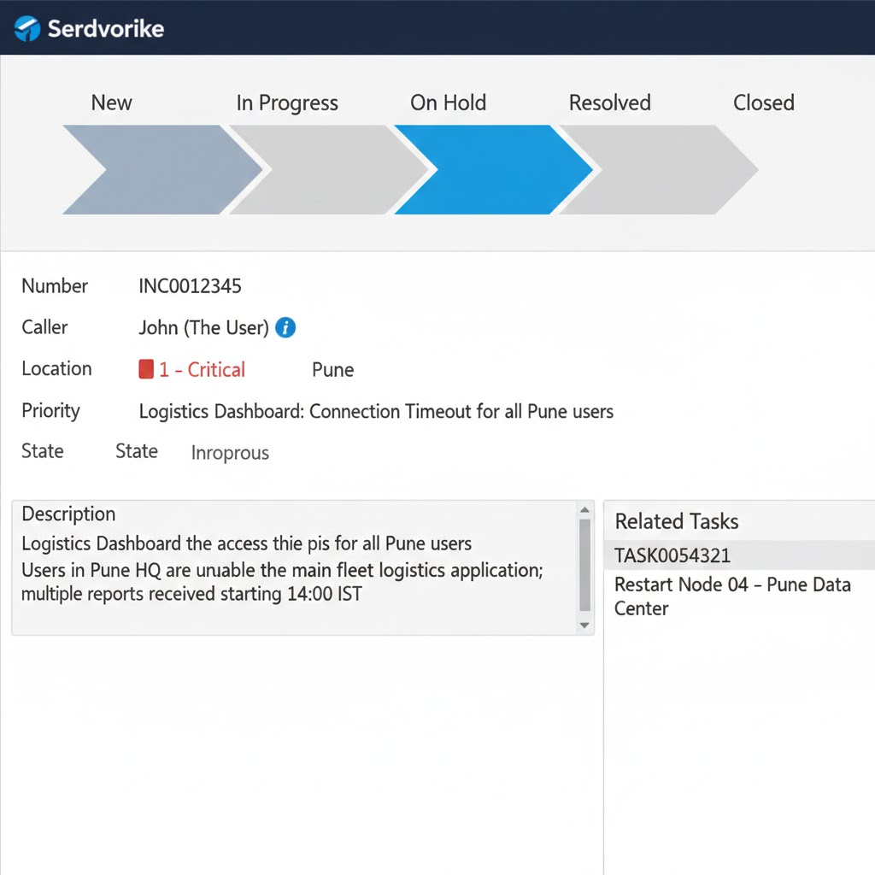
https://dev318910.service-now.com/navpage.do
admin
Jan30

Step 1: Create the Process Flow Stages
- Navigate to System UI > Process Flow.
- Click New to create a stage (Repeat this for each state).
- Example for "In Progress":
  - Table: Incident [incident]
  - Name: In Progress
  - Order: 200
  - Condition: State | is | In Progress
- Create others for New (100), On Hold (300), Resolved (400), and Closed (500).
Step 2: Add the Formatter to the Incident Form
- Open any Incident record.
- Right-click the header and go to Configure > Form Layout.
- In the "Available" list (left side), look for Process Flow.
- Move it to the Selected list (right side).
- Placement: Put it at the very top (above the "Number" field).
- Click Save.
Step 3: Verification
- Change the state of an Incident from New to In Progress.
- Save the record.
- You should see the horizontal chevron bar update, highlighting "In Progress" in blue or green.

